Summary of Thesis Results Thus Far

1. ANOVA/ Mann Whitney U-Test to compare the mean species richness between Projects and BEC vs. 2025 surveys. Done WITHOUT grass, mosses and lichens (functional groups) in the BEC data:
- Analyzing this will allow me to determine whether or not I need to control for systemic differences in survey effort and rarify the species identified in the 2025 resurveys.
ProjectID | n_plots | Mean 2025 richness | Mean BEC Richness | SD richness 2025 | SD richness BEC
Alpine2007_BEC | 7 | 23 | 18.29 | 3.27 | 3.90
BC Parks Manning TEM | 10 | 25 | 23.10 | 7.64 | 5.67
BEC-Vancouver | 9 | 37.11 | 32.56 | 6.41 | 4.82
NCBG_ESSFplots | 18 | 26.33 | 14.17 | 8.09 | 4.87
RCOBEC15 | 1 | 28 | 20 | NA | NA
Skagit Rhodo. Comm. | 7 | 24.28 | 24 | 2.81 | 4.80

ProjectID | U statistic | p.value | method | alternative
Alpine2007_BEC | 40.5 | 0.045 | Wilcoxon rank sum test with continuity correction | two.sided
BC Parks Manning TEM | 58.5 | 0.544 | Wilcoxon rank sum test with continuity correction | two.sided
BEC-Vancouver | 60.5 | 0.084 | Wilcoxon rank sum test with continuity correction | two.sided
NCBG_ESSFplots | 292 | <0.001 | Wilcoxon rank sum test with continuity correction | two.sided
RCOBEC15 | 1 | 1 | Wilcoxon rank sum exact test | two.sided
Skagit Rhodo. Comm. | 24.5 | 1 | Wilcoxon rank sum test with continuity correction | two.sided

Key results:
- Statistically different:
- NCBG_ESSFplots (p < 0.001)
- Alpine2007_BEC (p = 0.045)

Graphs:
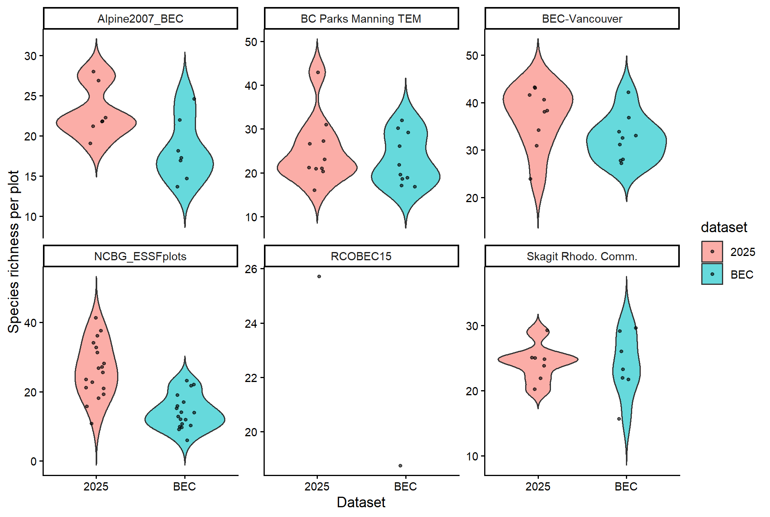

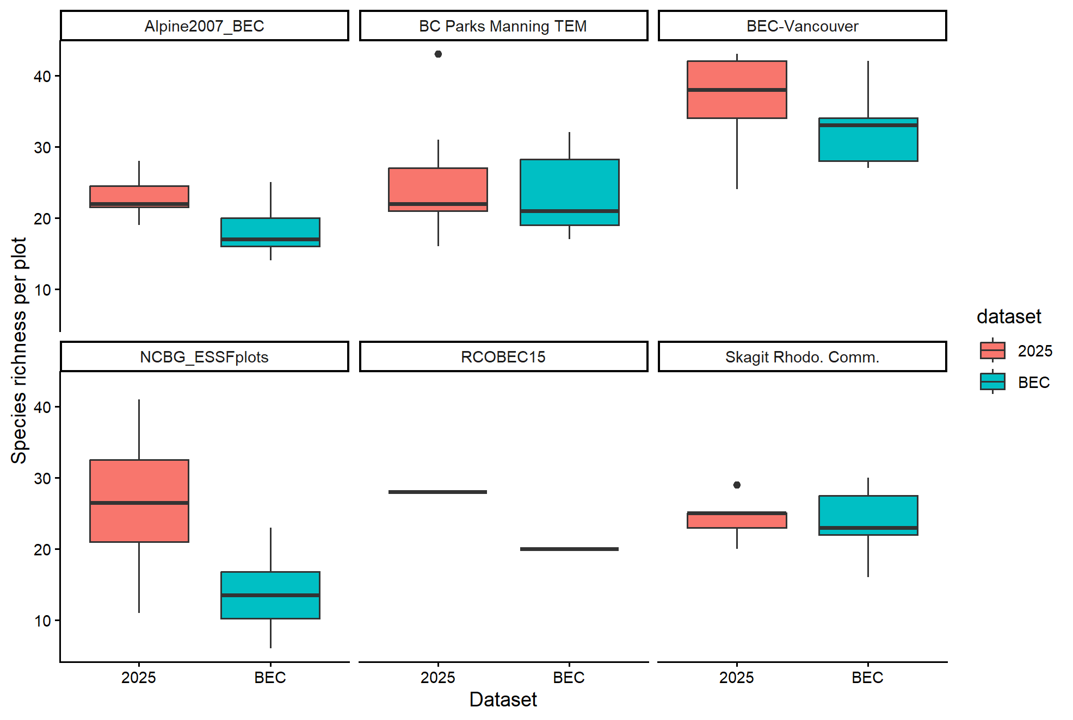
Conclusions:
- In chatting with Amy, while NCBG_ESSFplots and Alpine2007_BEC projects differed significantly, for the scope of an Honours Thesis, I can defend the choice not to rarefy species from these projects.
- Additionally, rarifying in general, when there are no obvious systemic differences in sampling effort across projects, eliminates the possibility that species richness has changed through time.
- Particularly for presence/ absence models, this is not a concern because we only work with the 30-36 most common species across all projects

2. Assessing the correlation between Survey Year and Elevation:
- Using Pearson's product-moment correlation (cor.test() in R) and model_data.csv, I tested the correlation between survey year and elevation to test if surveys tended to be conducted higher in elevation through time
Data used | cor | p-value | df | 95% CI
model_data.csv  (filtered out data from 2025) | 0.511042 | 2.2e-16 | 1870 | 0.4767757,  0.5437575

Graphs:
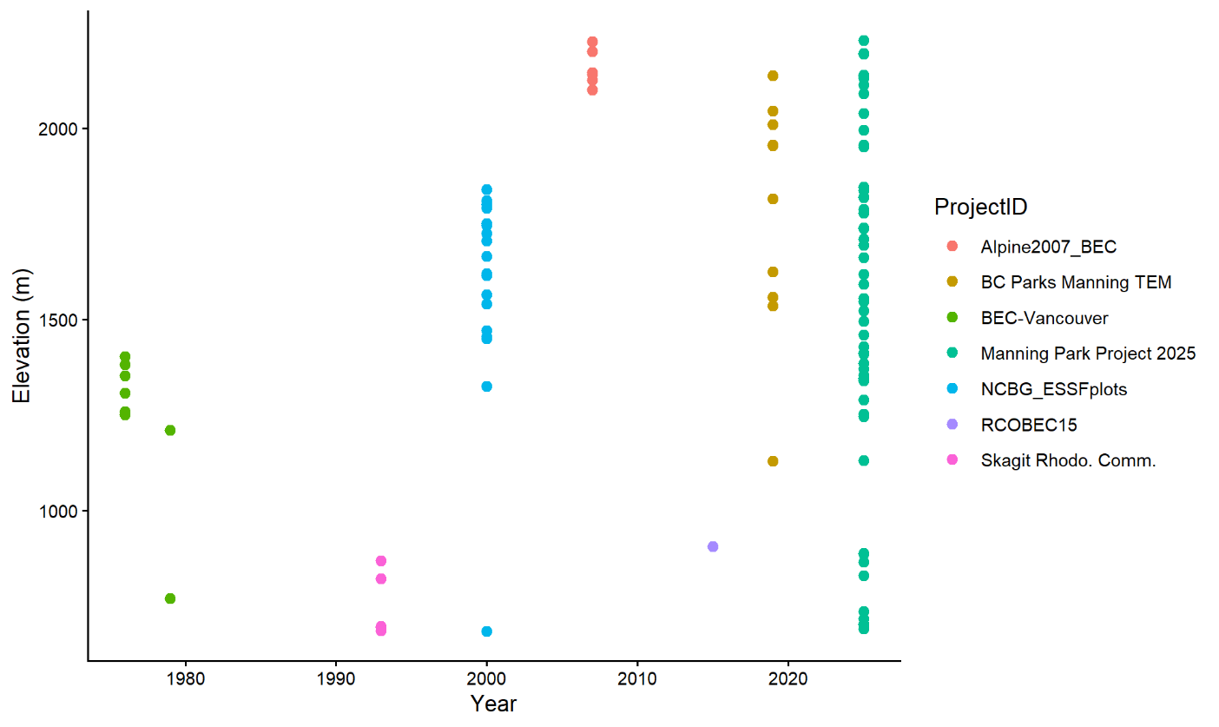
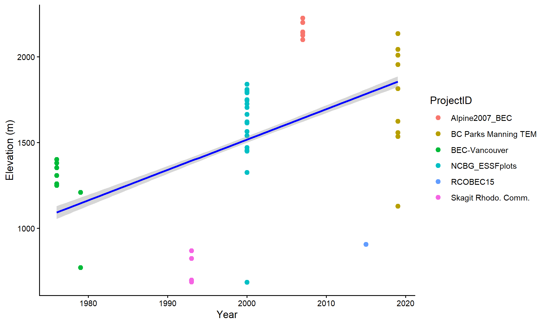
Figure X. The relationship between BEC sampling year and elevation (cor = 0.511, p = 2.2e-16). Each colour corresponds to a different project, and each dot represent a plot resurveyed within that project.

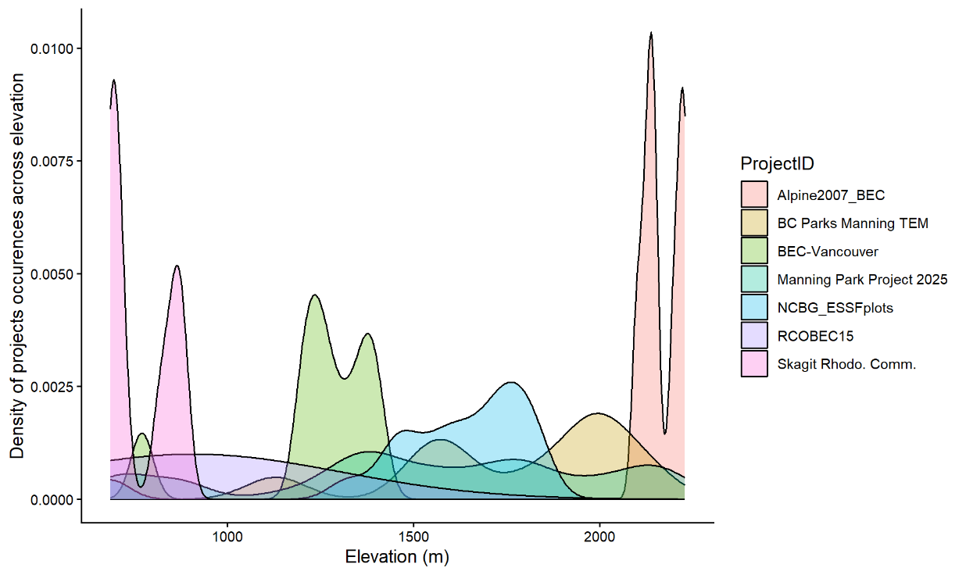
Figure X. The density of projects surveyed across elevation. Each colour corresponds to a separate project. Density corresponds to …. BAD figure for science but it’s pretty!
The relationship between BEC sampling year and elevation (cor = 0.511, p = 2.2e-16). Each colour corresponds to a different project, and each dot represent a plot resurveyed within that project.
Results:
- Survey year and plot elevation were positively correlated (Pearson r = 0.51, p < 2.2e-16), indicating that later surveys tended to occur at higher elevations. This reflects a shift in sampling towards higher elevations over time.
- This correlation may be impossible to separate from any year*elevation signal detected by continuous time models.
- As discussed, due to this correction, we threw out plots from 2007, 2015, and 2019. We then binned together all plots from <2000 and labelled them “historical” and compared them to their paired 2025 resurveys. This broke the Year*Elevation correlation and allowed us to isolate the time*elevation relationship of species.

3. BEST GLMM WITH CONTINUOUS TIME. Model selection of generalized linear mixed models to detect change in the presence of species occurrences over time and across elevation (CONTINUOUS MODEL)
Table X. Best fitting GLMM structure and fit of the continuous time model.
Response variable | Model type | Fixed effects | Random effects | Observations (n) | Species (n) | Plots (n) | AIC
Species presence | GLMM (binomial, logit) | Time × (Elevation + Elevation²) + Latitude + Longitude | (Elevation + Elevation² | Species) + (1 | Plot) | 3744 | 36 | 52 | 3402.5

Table X. Fixed effects from the GLMM for continuous time.
Predictor | Estimate | Std. Error | z value | p-value
Intercept | 0.189 | 0.267 | 0.708 | 0.479
Time | 0.351 | 0.056 | 6.225 | <0.001 ***
Elevation | -1.737 | 0.392 | -4.432 | <0.001***
Elevation² | -1.980 | 0.217 | -9.124 | <0.001***
Latitude | 0.523 | 0.143 | 3.661 | <0.001***
Longitude | -0.347 | 0.133 | -2.601 | 0.009 **
Time × Elevation | 0.308 | 0.092 | 3.350 | <0.001***
Time × Elevation² | 0.109 | 0.063 | 1.729 | 0.084 .
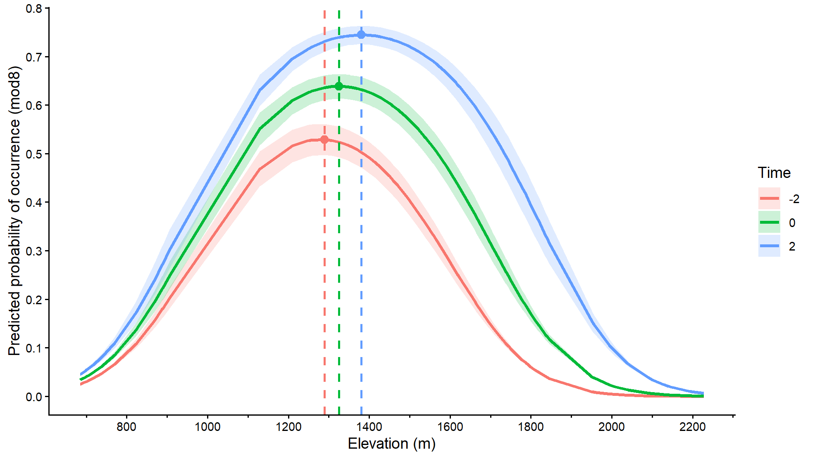
Figure X. Predicted probability of species occurrence across the elevational gradient from the continuous generalized linear mixed model (mod8), generated using ggpredict. Curves show predictions at −2, 0, and +2 standard deviations of scaled time (red, green, and blue), with shaded 95% confidence intervals. Points and dashed lines indicate the elevation of maximum predicted occurrence for each time point. ****Maybe I should include statistics in here?
- Exploring the response of Functional Groups
  - Added a Functional_group interaction to the Time*Elevation interaction. This did not significantly change the AIC value compared to the best continuous model (ΔAIC > 2). The AIC value was still significantly better than all other continuous model.
  - I painstakingly checked if the functional group interaction improved any of the other best performing models (NOT reported oops) and it did not. The added interaction increased the time it took for the model to converge significantly

Table X. Best fitting GLMM structure and fit of the continuous time model with a Functional_group interaction.
Response variable | Model type | Fixed effects | Random effects | Observations (n) | Species (n) | Plots (n) | AIC
Species presence | GLMM (binomial, logit) | Time × (Elevation + Elevation²) × Functional group+ Latitude + Longitude | (Elevation + Elevation² | Species) + (1 | Plot) | Total: 3744  Herb: 1560  Shrub: 1456  Tree: 728 | 36 | 52 | 3404.4

Table X. Fixed effects from the continuous GLMM with a functional group interaction. Coefficients are calculated relative to the change observed by the functional group “Herb”.
Predictor | Estimate | Std. Error | z value | p-value
Intercept | 0.180 | 0.375 | 0.48 | 0.631
Time | 0.432 | 0.083 | 5.20 | <0.001 ***
Elevation | -1.218 | 0.566 | -2.15 | 0.032 *
Elevation² | -2.036 | 0.280 | -7.26 | <0.001 ***
Shrub (vs herb) | 0.114 | 0.497 | 0.23 | 0.818
Tree (vs herb) | -0.140 | 0.615 | -0.23 | 0.820
Latitude | 0.528 | 0.144 | 3.67 | <0.001 ***
Longitude | -0.351 | 0.134 | -2.61 | 0.009 **
Time × Shrub | -0.135 | 0.117 | -1.16 | 0.247
Time × Tree | -0.215 | 0.150 | -1.43 | 0.152
Elevation × Shrub | -0.931 | 0.795 | -1.17 | 0.241
Elevation² × Shrub | -0.214 | 0.355 | -0.60 | 0.548
Elevation × Tree | -0.795 | 0.978 | -0.81 | 0.416
Elevation² × Tree | 0.663 | 0.432 | 1.53 | 0.125
Time × Elevation × Herb | 0.515 | 0.131 | 3.94 | <0.001 ***
Time × Elevation² × Herb | 0.208 | 0.095 | 2.18 | 0.029 *
Time × Elevation × Shrub | -0.360 | 0.197 | -1.83 | 0.068 .
Time × Elevation² × Shrub | -0.090 | 0.140 | -0.65 | 0.519
Time × Elevation × Tree | -0.499 | 0.235 | -2.13 | 0.034 *
Time × Elevation² × Tree | -0.352 | 0.159 | -2.21 | 0.027 *
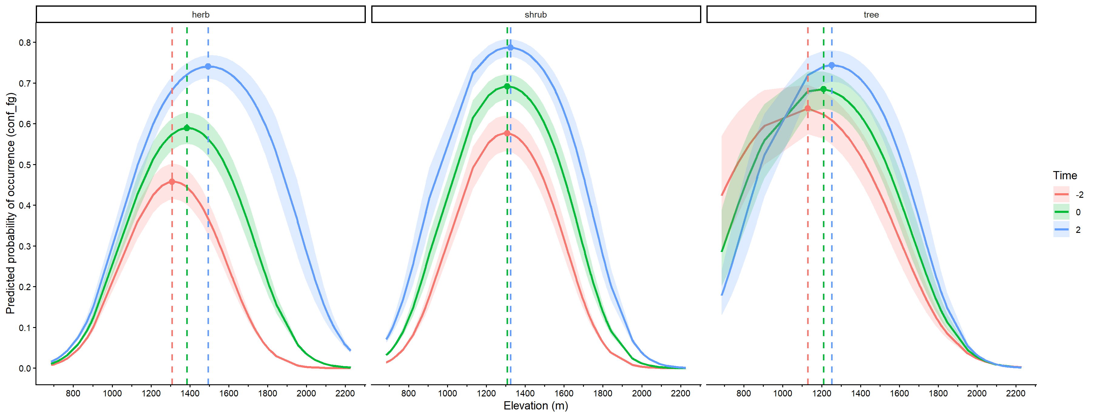
Figure X. Predicted probability of species occurrence across the elevational gradient from the continuous generalized linear mixed model separated by functional group (fgmod8), generated using ggpredict. Curves show predictions at −2, 0, and +2 standard deviations of scaled time (red, green, and blue), with shaded 95% confidence intervals. Points and dashed lines indicate the elevation of maximum predicted occurrence for each time point. ****Maybe I should include statistics in here?

4. BEST GLMM WITH CATEGORICAL TIME. Model selection of generalized linear mixed models to detect change in the presence of species occurrences over time and across elevation (CATEGORICAL MODEL)
- Binned together all plots from 1976-2000 and labelled them “historical”. Compared them to their paired resurveys in 2025
Table X. Best fitting GLMM structure and fit of the categorical time model.
Response variable | Model type | Fixed effects | Random effects | Observations (n) | Species (n) | Plots (n) | AIC
Species presence | GLMM (binomial, logit) | Time × (Elevation + Elevation²) + Latitude | (Elevation + Elevation² | Species) + (1 | Plot) | 2040 | 30 | 34 | 2154.8

Table X. Fixed effects from the GLMM for full categorical time model. BEC data from 1976-2000 have been binned together as “historical” data and compared to their paired 2025 resurveys.
Predictor | Estimate | Std. Error | z value | p-value
Intercept | 0.512 | 0.266 | 1.926 | 0.0541 .
Time (present vs past) | 0.530 | 0.160 | 3.323 | 0.000891 ***
Elevation | -0.267 | 0.340 | -0.786 | 0.432
Elevation² | -1.239 | 0.198 | -6.244 | <0.001 ***
Latitude | 0.740 | 0.190 | 3.897 | <0.001 ***
Time × Elevation | 0.352 | 0.147 | 2.400 | 0.016 *
Time × Elevation² | 0.122 | 0.139 | 0.881 | 0.378

Graphs:
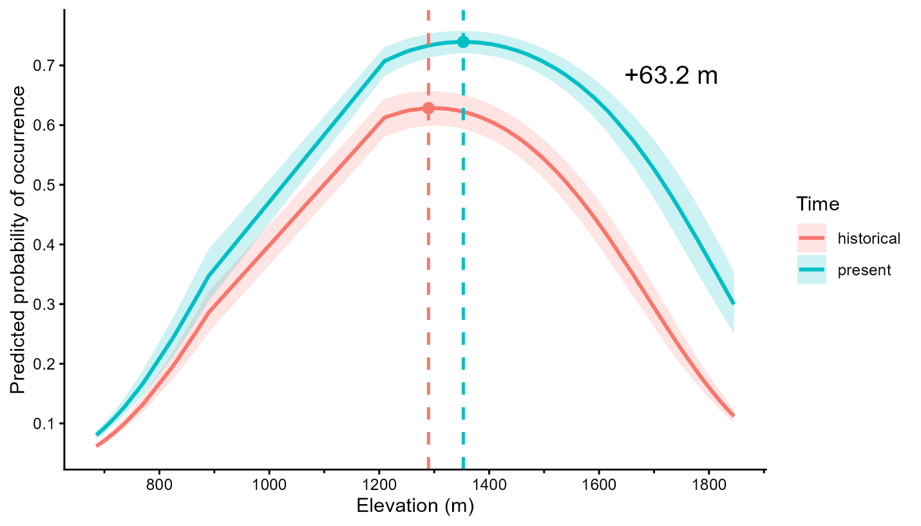
Figure X. Predicted probability of species occurrence across the elevational gradient from the categorical generalized linear mixed model (mod8.4), generated using ggpredict. Curves show predictions at the historical time point (1976-2000, red) and the present time point (2025, blue). The shaded areas represent the 95% confidence intervals. Points and dashed lines indicate the elevation of maximum predicted occurrence for each time point.

Table X. Best fitting GLMM structure and fit of the categorical time model with a functional group interaction.
Response variable | Model type | Fixed effects | Random effects | Observations (n) | Species (n) | Plots (n) | AIC
Species presence | GLMM (binomial, logit) | Time × (Elevation + Elevation²) × Functional_group + Latitude | (Elevation + Elevation² | Species) + (1 | Plot) | Total: 2040  Herb: 748  Shrub: 884  Tree: 408 | 30 | 34 | 2156.2

Table X. Fixed effects from a binomial GLMM testing changes in species occurrence across time (historical vs. present), elevation (linear and quadratic), and functional group for the full model. Coefficients are on the logit scale and relative to herb species and the historical time period.
Predictor | Estimate | Std. Error | z value | p-value
Intercept | 0.445 | 0.382 | 1.164 | 0.244
Time (present vs historical) | 0.463 | 0.255 | 1.817 | 0.069 .
Elevation | -0.333 | 0.530 | -0.628 | 0.530
Elevation² | -1.530 | 0.298 | -5.135 | <0.001 ***
Shrub (vs herb) | -0.026 | 0.471 | -0.055 | 0.956
Tree (vs herb) | 0.465 | 0.596 | 0.781 | 0.435
Latitude | 0.767 | 0.195 | 3.940 | <0.001 ***
Time × Elevation | 0.805 | 0.259 | 3.104 | 0.0019 **
Time × Elevation² | 0.611 | 0.240 | 2.545 | 0.0109 *
Time × Shrub | 0.211 | 0.351 | 0.600 | 0.549
Time × Tree | -0.196 | 0.452 | -0.434 | 0.664
Elevation × Shrub | 0.345 | 0.678 | 0.509 | 0.611
Elevation² × Shrub | 0.270 | 0.357 | 0.755 | 0.450
Elevation × Tree | -0.339 | 0.841 | -0.404 | 0.686
Elevation² × Tree | 0.679 | 0.440 | 1.542 | 0.123
Time × Elevation × Shrub | -0.715 | 0.332 | -2.155 | 0.031 *
Time × Elevation² × Shrub | -0.581 | 0.317 | -1.833 | 0.067 .
Time × Elevation × Tree | -0.754 | 0.416 | -1.812 | 0.070 .
Time × Elevation² × Tree | -1.005 | 0.392 | -2.562 | 0.010 *

Table X. Pairwise contrasts of elevational trends between time periods (historical and present) within each functional group using emtrends().
Functional group | Contrast | Estimate | Std. Error | p-value
Herb | Historical - Present | -0.807 | 0.260 | 0.0019
Shrub | Historical -Present | -0.091 | 0.215 | 0.673
Tree | Historical -Present | -0.050 | 0.329 | 0.880

Table X. Pairwise contrasts of trends in probability of occurrence between time periods (historical and present) within each functional group using emmeans().
Functional group | Contrast | Estimate | Std. Error | p-value
Herb | Historical – Present | -0.463 | 0.255 | 0.069
Shrub | Historical – Present | -0.674 | 0.243 | 0.0056
Tree | Historical – Present | -0.267 | 0.374 | 0.474

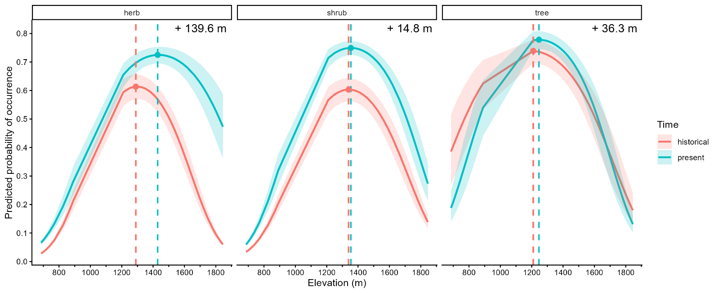
Figure X. Predicted probability of species occurrence across the elevational gradient from the categorical generalized linear mixed model separated by functional group, generated using ggpredict. Curves show predictions at the historical time point (1976-2000, red) and the present time point (2025, blue). The shaded areas represent 95% confidence intervals. Points and dashed lines indicate the elevation of maximum predicted occurrence for each time point.

5. SENSITIVITY ANALYSIS: Filtering out low-confidence plots in the GLMM model

Table X. Sensitivity analysis of the time × elevation interaction across relocation confidence thresholds
Dataset | Observations (n) | β (Time × Elevation) | Std. Error | p-value
Full dataset | 2040 | 0.352 | 0.147 | 0.016
Medium+ confidence | 1612 | 0.353 | 0.159 | 0.026
Med-high+ confidence | 1144 | 0.529 | 0.187 | 0.0047

Table X. Best fitting GLMM structure and fit of the categorical time model. Plots with low relocation confidence have been filtered out.
Response variable | Model type | Fixed effects | Random effects | Observations (n) | Species (n) | Plots (n) | AIC
Species presence | GLMM (binomial, logit) | Time × (Elevation + Elevation²) + Latitude | (Elevation + Elevation² | Species) + (1 | Plot) | 1612 | 26 | 31 | 1729.0

Table X. Fixed effects from the GLMM for the categorical time model. BEC data from 1976-2000 have been binned together as “historical” data and compared to their paired 2025 resurveys.
Predictor | Estimate | Std. Error | z value | p-value
Intercept | 0.627 | 0.294 | 2.13 | 0.033 *
Time (present vs past) | 0.503 | 0.182 | 2.76 | 0.006 **
Elevation | 0.006 | 0.358 | 0.02 | 0.987
Elevation² | -1.153 | 0.202 | -5.71 | <0.001 ***
Latitude | 0.835 | 0.206 | 4.05 | <0.001***
Time × Elevation | 0.353 | 0.159 | 2.22 | 0.026 *
Time × Elevation² | 0.105 | 0.156 | 0.67 | 0.500

Table X. Fixed effects from the GLMM for conf categorical time model. BEC data from 1976-2000 have been binned together as “historical” data and compared to their paired 2025 resurveys.
Predictor | Estimate | Std. Error | z value | p-value
Intercept | 0.627 | 0.294 | 2.134 | 0.033 *
Time (present vs historical) | 0.503 | 0.182 | 2.758 | 0.0058 **
Elevation | 0.006 | 0.358 | 0.016 | 0.987
Elevation² | -1.153 | 0.202 | -5.709 | <0.001 ***
Latitude | 0.835 | 0.206 | 4.053 | <0.001 ***
Time × Elevation | 0.353 | 0.159 | 2.224 | 0.026 *
Time × Elevation² | 0.105 | 0.156 | 0.674 | 0.500

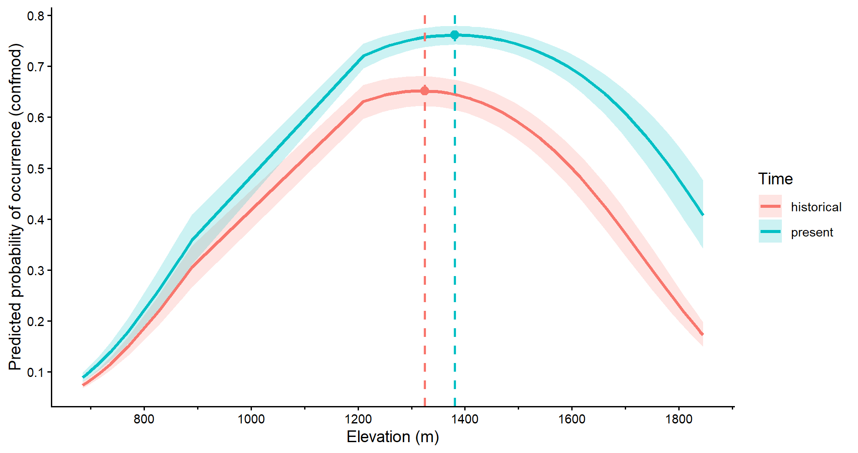
Graphs:
Figure X. Predicted probability of species occurrence across the elevational gradient from the categorical generalized linear mixed model (mod8), generated using ggpredict. Curves show predictions at the historical time point (1976-2000, red) and the present time point (2025, blue). The shaded areas represent the 95% confidence intervals. Points and dashed lines indicate the elevation of maximum predicted occurrence for each time point.

Relocation Error Analysis

Ideas for relocation error
- Is there any detectable change in 6 years? I’m guessing no
  - If there is change, how do the error plots change that detectability
- If we decide there is no detectable change, how does comparing 2019 plots to the error relocation plots change that
- Quantify how much resurvey and error plots differ from each other
  - Bray-Curtis turnover or Jaccard for similarity
  - Quantify how they change relocation trends
- Which metrics are most influenced by relocation error?
  - Species richness
  - Turnover
  - Beta diversity among plots along an elevation gradient

- Paired t-test of Bray-Curtis and Jaccard dissimilarity (beta diversity) between 2019/2025 and 2019/Error plots
To assess whether relocation error was comparable to temporal community turnover, we compared within-site dissimilarity between the 2019 plot and its paired 2025 plot against dissimilarity between the 2019 plot and its paired error plot. We evaluated this using both Bray-Curtis dissimilarity, which incorporates species cover, and Jaccard dissimilarity, which uses species presence–absence only.
Paired differences met the assumptions for parametric testing. For Bray-Curtis dissimilarity, Shapiro–Wilk tests indicated no evidence of non-normality in the paired differences (W = 0.928, p = 0.463). The same was true for Jaccard dissimilarity (W = 0.881, p = 0.161). Paired t-tests therefore were considered appropriate, with Wilcoxon signed-rank tests used as a non-parametric check.
Under Bray-Curtis dissimilarity, mean dissimilarity between 2019 and error plots was slightly greater than mean dissimilarity between 2019 and 2025 plots, but this difference was not significant (mean paired difference = 0.038, 95% CI = -0.066 to 0.143, t = 0.850, df = 8, p = 0.420). The Wilcoxon signed-rank test gave the same conclusion (V = 29, p = 0.496). Jaccard dissimilarity showed the same pattern: mean dissimilarity between 2019 and error plots was slightly greater than between 2019 and 2025 plots, but again the difference was not significant (mean paired difference = 0.019, 95% CI = -0.030 to 0.068, t = 0.907, df = 8, p = 0.391). The Wilcoxon signed-rank test also did not detect a difference (V = 23, p = 0.529).

Table X. Paired comparisons of within-site community dissimilarity between 2019 vs. 2025 plots and 2019 vs. error plots. Positive mean differences indicate that 2019 vs. error dissimilarity was greater than 2019 vs. 2025 dissimilarity.
Metric | Mean Difference (Error − 2025) | 95% CI | t (df = 8) | p (t-test) | p (Wilcoxon)
Bray-Curtis | 0.0385 | -0.0659, 0.143 | 0.850 | 0.420 | 0.496
Jaccard | 0.0191 | −0.0295, 0.0675 | 0.907 | 0.391 | 0.529

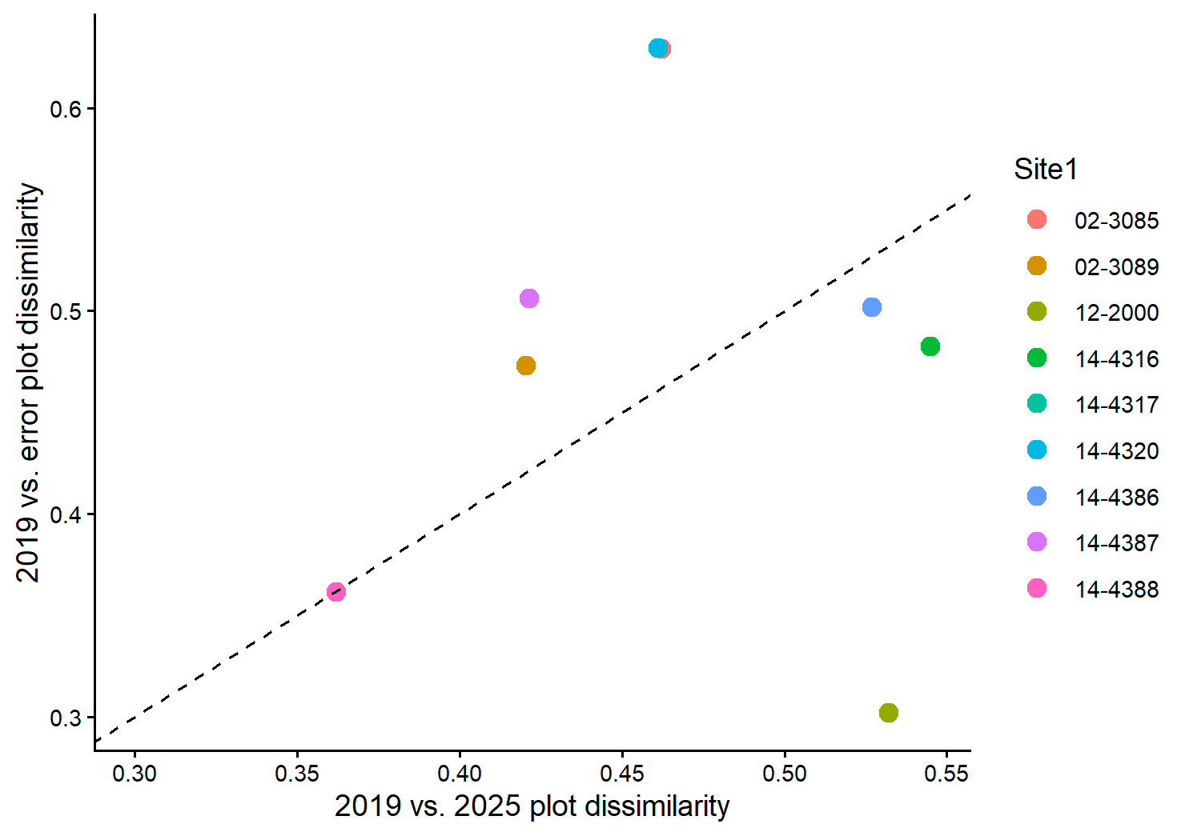
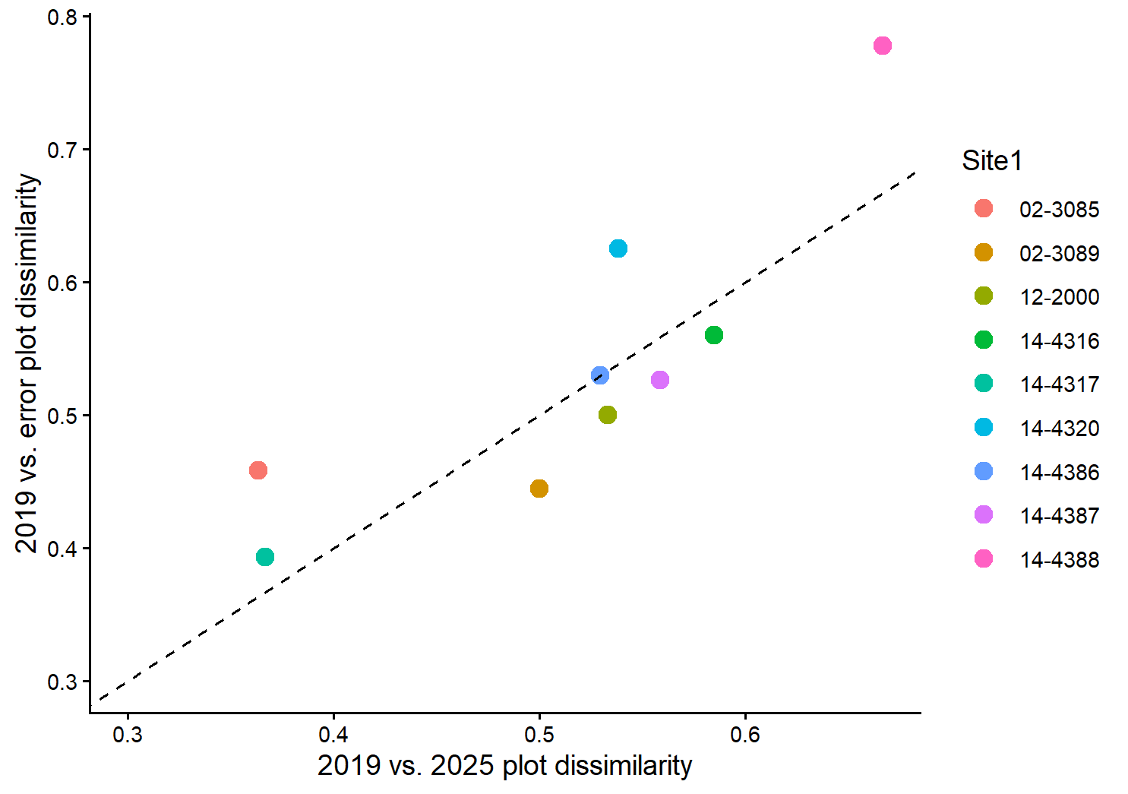
Figure X. Within-site dissimilarity between 2019 and 2025 plots plotted against within-site dissimilarity between 2019 and error plots for (a) Bray-Curtis and (b) Jaccard dissimilarity. The dashed 1:1 line indicates equal dissimilarity. Points above the line indicate sites where relocation error exceeded temporal turnover, whereas points below the line indicate sites where temporal turnover exceeded relocation error.

To test whether community composition differed among treatments overall, we used PERMANOVA with site-constrained permutations.
Community composition differed significantly among treatments in the overall PERMANOVA for both abundance-weighted Bray–Curtis dissimilarity and presence–absence Jaccard dissimilarity. For Bray–Curtis, treatment explained 4.1% of the total variation in composition (PERMANOVA: F = 0.511, R² = 0.0408, p = 0.0004). For Jaccard, treatment explained 4.3% of the total variation (F = 0.535, R² = 0.0427, p = 0.0005). Although these treatment effects were statistically significant, effect sizes were small for both metrics.
Pairwise PERMANOVAs showed that this overall treatment effect was driven by differences between the 2019 plots and both the 2025 and error plots, whereas 2025 and error plots did not differ from one another. Under Bray–Curtis dissimilarity, 2019 differed from 2025 (F = 0.574, R² = 0.0346, p = 0.0039) and from Error (F = 0.760, R² = 0.0453, p = 0.0039), but 2025 did not differ from Error (F = 0.195, R² = 0.0121, p = 0.7305). The same pattern was observed with Jaccard dissimilarity: 2019 differed from 2025 (F = 0.653, R² = 0.0392, p = 0.0078) and from Error (F = 0.790, R² = 0.0470, p = 0.0039), whereas 2025 and Error did not differ (F = 0.142, R² = 0.0088, p = 0.8398).
Tests of multivariate dispersion were non-significant for both Bray–Curtis (ANOVA: F = 0.298, p = 0.745; permutation test: p = 0.738) and Jaccard (ANOVA: F = 0.797, p = 0.462; permutation test: p = 0.456), indicating that the PERMANOVA results were not driven by unequal within-group dispersion.
NMDS ordinations provided an acceptable representation of the multivariate data in two dimensions (Bray–Curtis stress = 0.117; Jaccard stress = 0.090). Consistent with the PERMANOVA results, ordinations showed broad overlap among treatments, with only weak separation of group centroids. Overall, these results indicate that both 2025 and error plots were compositionally distinct from the 2019 plots, but not from each other. This suggests that the observed difference between 2019 and 2025 plots was not unique to the 2025 resurveys, and was similar in magnitude and direction to the difference between 2019 and relocation-error plots.

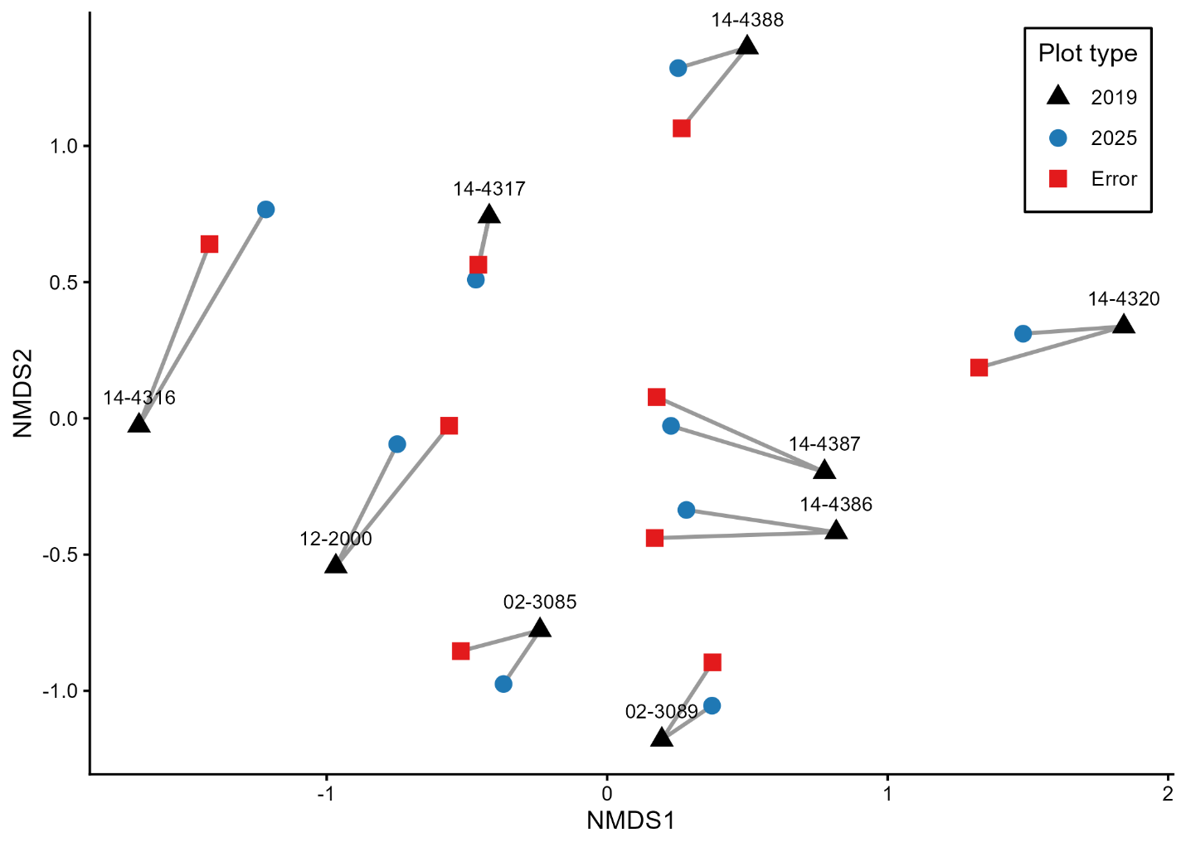

Figure X. Non-metric multidimensional scaling (NMDS) ordination of plots based on Bray-Curtis dissimilarity. Points represent plots, colours and shapes indicate treatment, and grey lines connect plots from the same site. Stress = 0.117.
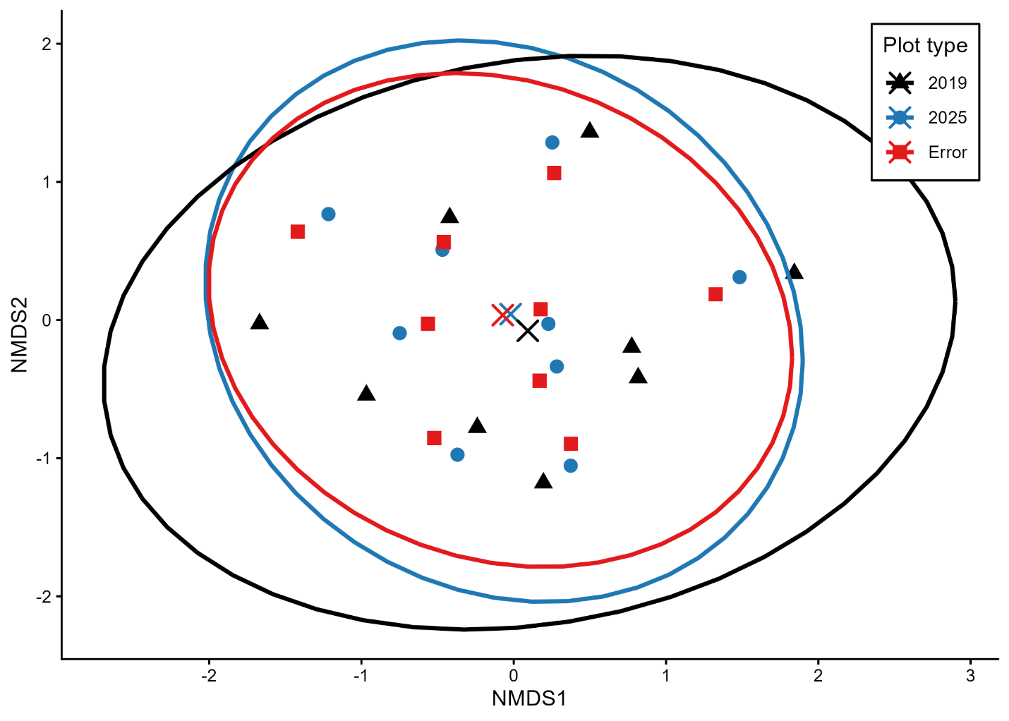

Figure X. NMDS ordination of plots based on Bray-Curtis dissimilarity showing treatment centroids and 95% confidence ellipses. Points represent individual plots and crosses represent treatment centroids.
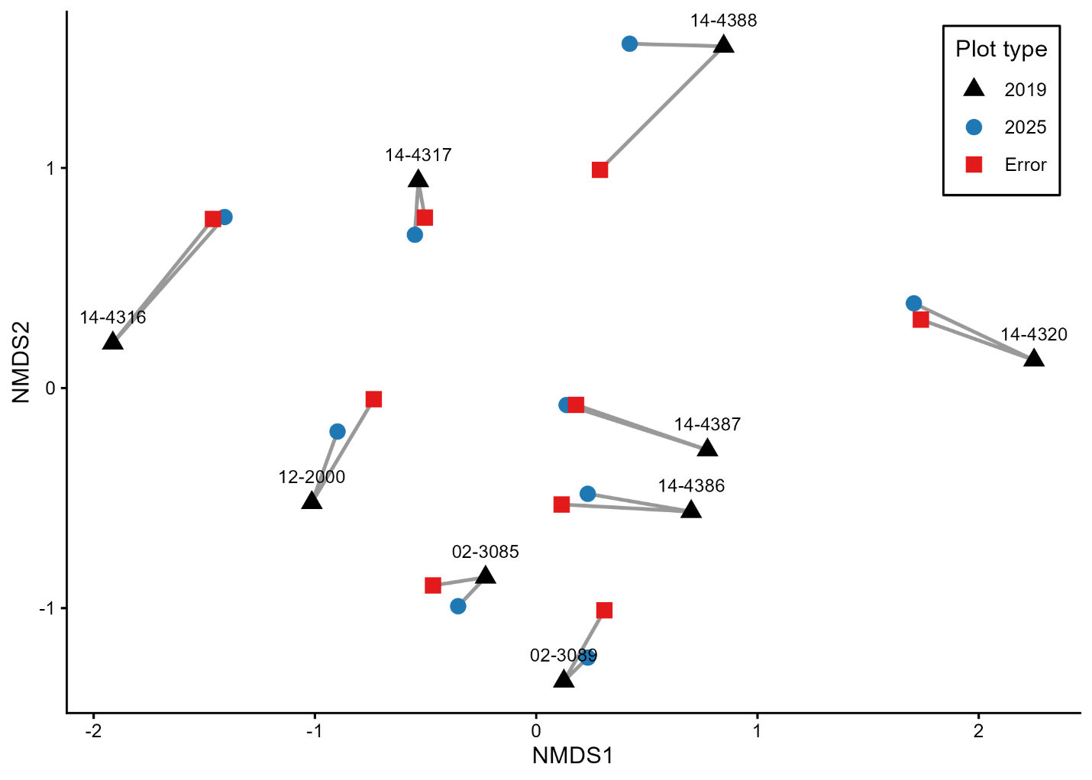

Figure X. NMDS ordination of plots based on Jaccard dissimilarity. Points represent plots, colours and shapes indicate treatment, and grey lines connect plots from the same site. Stress = 0.090.
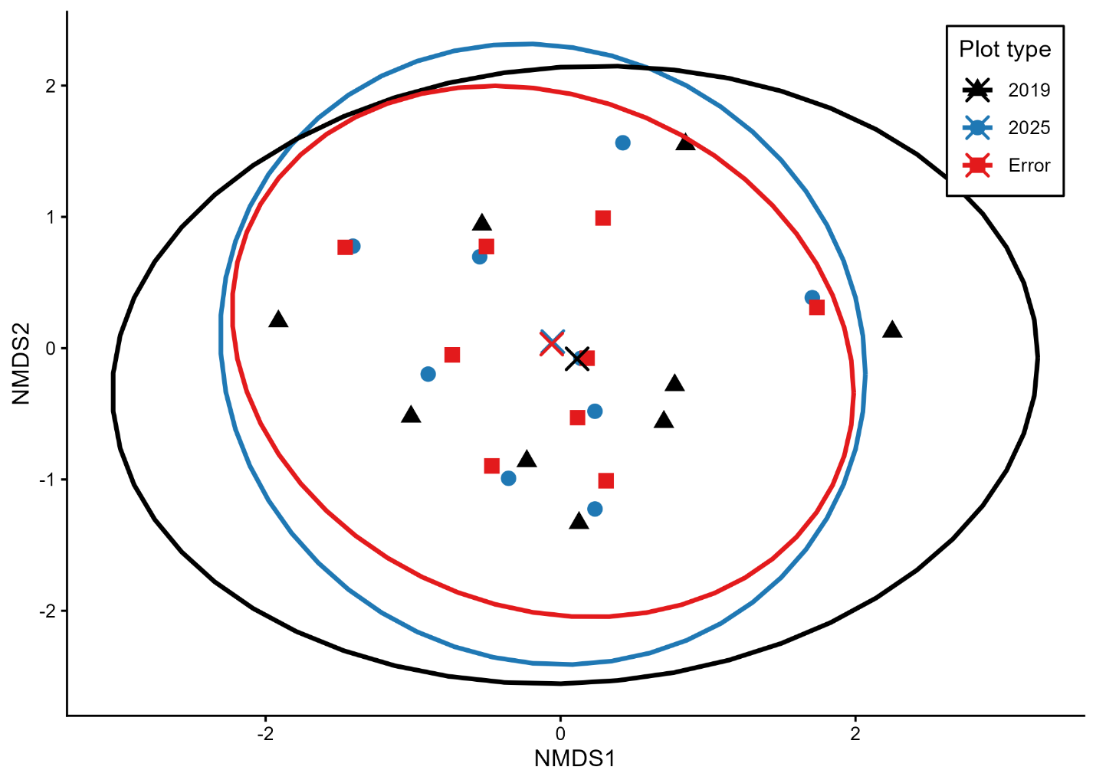

Figure X. NMDS ordination of plots based on Jaccard dissimilarity showing treatment centroids and 95% confidence ellipses. Points represent individual plots and crosses represent treatment centroids.
Overall, relocation error did not differ detectably from temporal turnover under either Bray-Curtis or Jaccard dissimilarity. Although treatments differed significantly in overall multivariate composition, these effects were small, and no difference was detected between 2025 and error plots for either distance metric.

Table X. Pairwise PERMANOVA results comparing community composition between treatments using Bray-Curtis (abundance) and Jaccard (presence–absence) dissimilarity. Site was used as a blocking factor (strata).
Comparison | Metric | R² | F | p-value
2019 vs 2025 | Bray–Curtis | 0.0285 | 0.470 | 0.871
2019 vs Error | Bray–Curtis | 0.0755 | 1.306 | 0.172
2025 vs Error | Bray–Curtis | 0.0208 | 0.340 | 0.969
2019 vs 2025 | Jaccard | 0.0250 | 0.411 | 0.938
2019 vs Error | Jaccard | 0.0632 | 1.079 | 0.242
2025 vs Error | Jaccard | 0.0244 | 0.400 | 0.984

Relocation error and community change
Species richness
Species richness did not differ among treatments (all p > 0.2; Table X), indicating that the number of species present remained consistent between original (2019), revisited (2025), and mislocated plots.
Community composition (Bray–Curtis)
Community composition differed among treatments when accounting for site-level pairing (PERMANOVA: R² = 0.040, p = 0.0007; Table X). Pairwise comparisons showed that communities in 2019 differed from both 2025 (R² = 0.034, p = 0.0039) and mislocated plots (R² = 0.044, p = 0.0078), whereas 2025 and mislocated plots did not differ (R² = 0.012, p = 0.73).
Tests of multivariate dispersion indicated no differences in within-group variability among treatments (F = 0.298, p = 0.747), supporting that observed differences reflect shifts in community composition rather than differences in dispersion.
Ordination using non-metric multidimensional scaling (NMDS; stress = 0.118) showed separation between 2019 plots and both 2025 and mislocated plots, while 2025 and mislocated plots largely overlapped (Figure X).
Community composition (Jaccard)
Presence–absence analyses showed consistent patterns. Community composition differed among treatments (PERMANOVA: R² = 0.041, p = 0.0007; Table X). Pairwise comparisons again indicated differences between 2019 and both 2025 (R² = 0.037, p = 0.0078) and mislocated plots (R² = 0.045, p = 0.0039), with no difference between 2025 and mislocated plots (R² = 0.009, p = 0.84).
Multivariate dispersion did not differ among treatments (F = 0.797, p = 0.452), indicating that results were not driven by differences in variability . NMDS ordination (stress = 0.091) showed the same pattern of separation and overlap as the abundance-based analysis (Figure X) .
Summary of relocation error results
Across both abundance-based and presence–absence analyses, community composition differed between 2019 and both 2025 and mislocated plots, while 2025 and mislocated plots did not differ from one another.

Table X. Mean (± SE) species richness across treatments representing original surveys (2019), revisited plots (2025), and intentionally mislocated plots (Error). Each treatment includes nine plots paired within sites
Treatment | Mean richness | SE | n
2019 | XX | XX | 9
2025 | XX | XX | 9
Error | XX | XX | 9

Table X. Results of permutational multivariate analyses of variance (PERMANOVA) testing for differences in plant community composition among treatments using both Bray-Curtis dissimilarity and Jaccard dissimilarity. Analyses were stratified by site to account for the paired sampling design.
Dissimilarity | Source | Df | R² | F | p-value
Bray-Curtis | Treatment | 2 | 0.040 | 0.500 | 0.0007 **
 | Residual | 24 | 0.960 | — | —
Jaccard | Treatment | 2 | 0.041 | 0.513 | 0.0007 **
 | Residual | 24 | 0.959 | — | —

Table X. Pairwise PERMANOVA comparisons of community composition among treatments using both Bray–Curtis and Jaccard dissimilarities.
Dissimilarity | Comparison | R² | F | p-value
Bray–Curtis | 2019 vs 2025 | 0.034 | 0.557 | 0.0039 **
 | 2019 vs Error | 0.044 | 0.745 | 0.0078 **
 | 2025 vs Error | 0.012 | 0.195 | 0.7305
Jaccard | 2019 vs 2025 | 0.037 | 0.616 | 0.0078 **
 | 2019 vs Error | 0.045 | 0.760 | 0.0039 **
 | 2025 vs Error | 0.009 | 0.142 | 0.8398

Table X. Tests of homogeneity of multivariate dispersion (PERMDISP) among treatments for both Bray–Curtis and Jaccard dissimilarities.
Dissimilarity | Source | Df | F | p-value
Bray–Curtis | Treatment | 2 | 0.298 | 0.747
Jaccard | Treatment | 2 | 0.797 | 0.452

